**Mobile UI Testing**

**Index 2:**

1.Spacing issue in the footer as compared to the mock.

**Mock:**

2. Spacing issue in business listing. Screen also able to drag from right to left. (shaky screen)



**Mock:**



**3. Alignment issue in Business listing.**

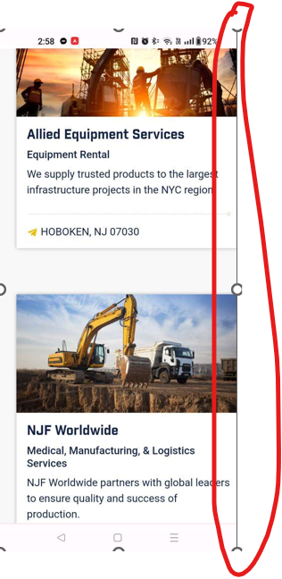

**4. Page navigation alignment issue in the business listing page.**

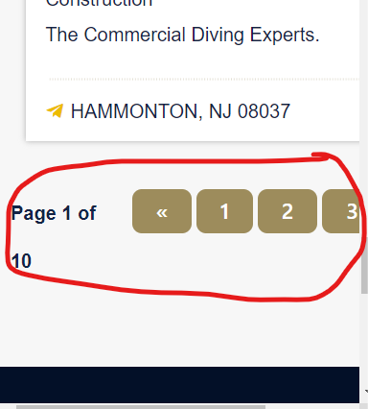

**5. Spacing issue in the login page**

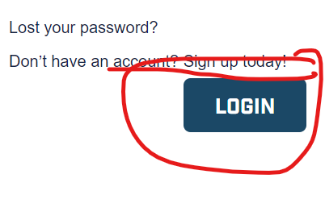

**Mock:**

**6. Alignment issue in the owner signup page.**

**Mock:**

**7. Spacing issue in the owner signup page.**

**Mock:**

**Portal:**

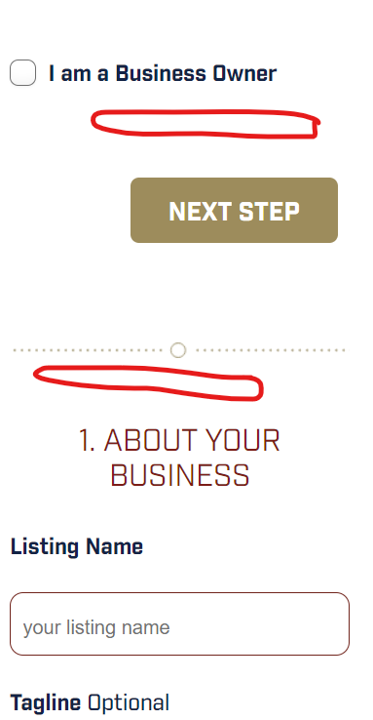

**8. Alignment issue in the reset password page. (Shake in the screen. Fix the shake also)**

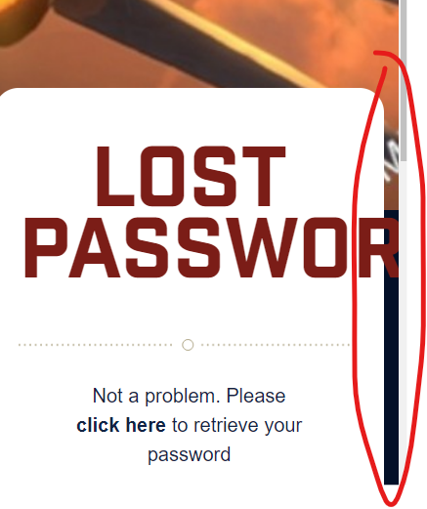

**Mock.**

